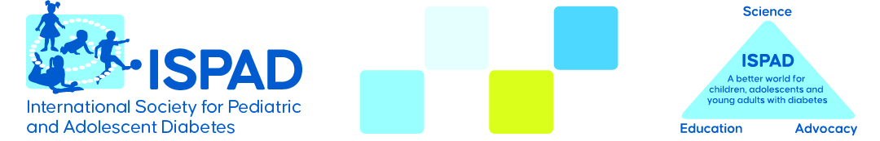

APPLICATION FOR HOSTING

ISPAD SCIENCE SCHOOL FOR PHYSICIANS 2026

Please submit your application before June 15, 2025. The submission should include information about the:
- Convener (Biosketch)
- Motivation
- Proposed location
- Proposed dates
- Practical organization and support for this
- Budget
- Financial support
- Outline of the program
(details to be discussed after acceptance)

To be sent to the ISPAD Secretary-General (jannet.svensson.01@regionh.dk) and secretariat@ispad.org

