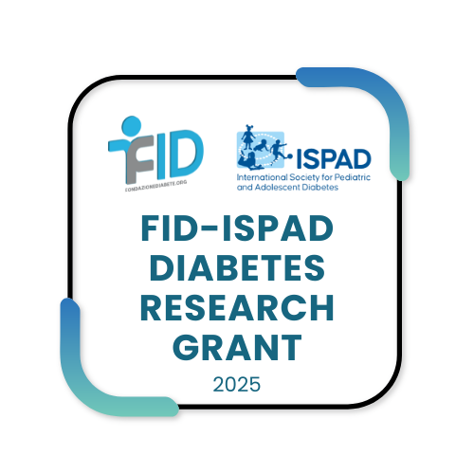

_______________________________

FID-ISPAD Research Program

Research Grant Application
Deadline for submission of applications: May 30, 2025

Important! Please send your application as one complete PDF email attachment by 12:00 midday (CEST) on the deadline date, to:
francesca.ulivi@fondazionediabete.org
secretariat@ispad.org

We only require an electronic version; please do not send paper copies.

General Information:
- Scope of the Research grant is related to the identification of a cure for type 1 diabetes, meaning a procedure or therapy that can ensure the normalization and maintenance over time of a normal glucose balance in the absence of external insulin administration. This category includes projects on pathogenesis, prediction, prevention, beta-cell replacement, organ and cell transplantation, tissue regeneration and stem cells, gene therapy.

- Explicitly excluded from funding is research on insulin, drugs, glucose sensor
technologies, or insulin infusers, which pertain to pharmaceutical and
biotechnology companies. Also excluded is research related to complications
of diabetes and research related to type 2 diabetes or forms of diabetes
other than type 1 diabetes.

- FID-ISPAD Research Grant program is only open to applicants from non-profit institutions or groups of such institutions.

- Applicant should be an ISPAD member. Awardee an investigator under 40Y will be a +. Applicant CV to be attached.

- It will be necessary for any current project supported by FID/ISPAD to be completed and a final scientific report submitted before new funding is requested.

1. Applicant Information

Title (Dr, Prof): _______________________________________
Age: _______________________________________
First/Second Name: _____________________________________________________
Institution name (anglicised version): ________________________________________
Postal address (anglicised version):_________________________________________
Telephone: ______________________ E-mail: _______________________________

Note: to attach the approval from the institution to which it belongs, which must declare its willingness to accept the funding and use it exclusively for the project being funded, define the so-called 'overhead' (i.e., the percentage retained by the institution, which must not exceed 10%) and ensure access to funding by the recipient.

+ CV

2. Application Details
Title of proposal:
______________________________________________________________________
______________________________________________________________________
Total budget : Euro _________________

This project is: Clinical Basic

Project Period: …… Months

From: To:

3. Scientific Abstract – FID-ISPAD Research Grant

PROJECT TITLE: __________________________________________________________

The application procedure includes the completion of a form structured in 6 paragraphs: title, background/rationale, objectives, study design, anticipated outcome, relevance to the cure of type1 diabetes; for a maximum length of 500 words in type no smaller than 12 points Arial with single line spacing and keep the abstract dedicated to this page.

Hereunder a guide for information only

• A clear relationship to the call diabetes must be obvious.
• Ensure that the sections in the proposal are balanced in length: a long introduction leaving too little space for preliminary data and a detailed work plan will decrease the chances of success.
• Be completely open about support from other sources, including support from pharmaceutical industry.
a. Introduction
1) Objective
2) Background and current status of research in the proposed field of study that has led to this proposal.
• Hypothesis: A carefully crafted introduction/background will make the formulation of the hypothesis obvious. This should be formulated as precisely and distinctly as

possible. Is it novel? Is it important? If the study is hypothesis-free or descriptive, this must be justified.
b. Detailed plan of investigation with clearly set out project plan, methods, time plans with milestones and deliverables

c. References (no page limit)

4. Ethical Approval
Will your project involve experiments requiring ethical approval/s?

Yes: No:

Should this application result in the granting of an award, a copy of the ethical human and/or animal approval/s will need to be attached to the grant activation documentation. Please do not attach approvals to this application form.

The approval/s must conform to the national laws of the country where the research is to be carried out.

Please note: No payments will be transferred until the appropriate approval/s have been granted and a copy received in the ISPAD or FID Office.

5.Budget
A detailed budget must be provided. The budget period (time) during which the sum requested will be spent according to the specific needs of the project must be clearly stated and justified where indicated. Please state your costs in Euros. If you are applying from a country outside the Euro Zone, please convert your local currency into Euros, using the exchange rate on the date of your application.
Total budget period (in months): _______________________________

Personnel:  (name if possible) | Role on  project | % Effort  on project |  | Institutional  base salary/Year | Salary  request *
Subtotal Euro:
Supplies (description): |  | Subtotal Euro ____________
Other costs (please specify): |  | Subtotal Euro ____________
Equipment (please describe) |  | Subtotal Euro ____________
SUBTOTAL DIRECT COSTS Euro ___________
INDIRECT COSTS (maximum 10% of Direct Costs) Euro __________
TOTAL BUDGET  (Including direct/indirect costs +salaries) |  |  | TOTAL Euro ___________

